

MEDIA OVERVIEW
Official count announced June 24, 2026
385  TREASURE CHESTS | $60,102  IN TREASURE | JULY 23  WORLDWIDE LAUNCH
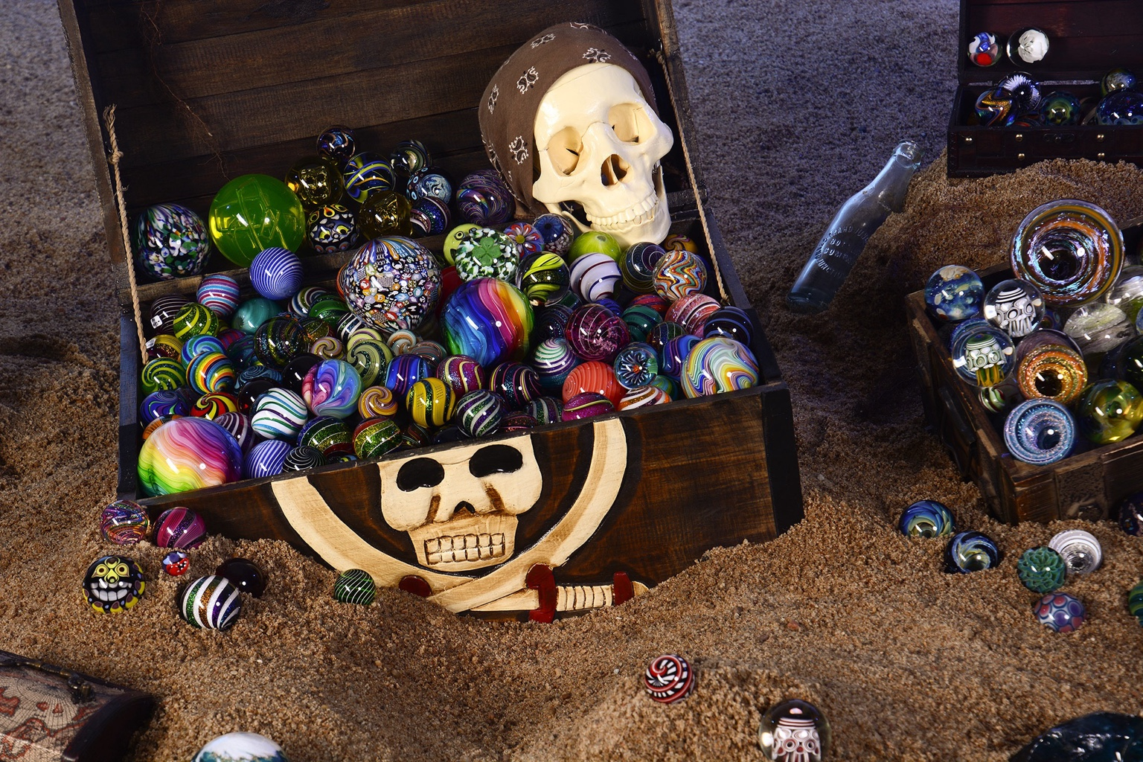  Original treasure display featuring handmade contemporary art marbles contributed by artists and collectors. | THE STORY IN 30 SECONDS  History has already been made before the first clue is posted - and on July 23, it will be hidden around the world. The World's Biggest Marble Hunt has confirmed 385 registered treasure chests with a combined reported value of $60,102, establishing the world's biggest organized multi-chest treasure hunt ever documented. Internationally recognized marble artists and leading glass studios are taking part, while thousands of additional individual handmade marbles are expected to be hidden worldwide.  PUBLIC PARTICIPATION  Anyone may follow the clues and hunt completely free. Each family may find and keep one official anniversary treasure chest plus up to two additional individual handmade marbles. Those two individual marble finds are in addition to the treasure chest. After reaching that limit, the family must hide an official anniversary treasure chest before continuing to hunt, carrying the pay-it-forward tradition forward.
KEY FACTS FOR REPORTERS
- The official count of 385 registered treasure chests establishes the world's biggest organized multi-chest treasure hunt ever documented and a new worldwide record for the number of individual chests coordinated in one organized public hunt.
- The chests contain $60,102 in registered handmade art and treasure, with bonus registrations still being added through July 20.
- Many internationally recognized marble artists and world-renowned glass studios are participating; hundreds of celebrated artists' marbles will be placed inside the 385 chests, while thousands of additional individual handmade marbles are expected to be hidden worldwide.
- Handmade contemporary art marbles are collectible works of glass art that may be valued from about $15 to thousands of dollars each.
- The World’s Biggest Marble Hunt Facebook group includes more than 40,000 members worldwide, and the public is invited to be part of history beginning July 23.
- Locations are chosen independently and revealed through clues; additional chests and individual marble hunts may continue through the end of 2026, and some mystery-location hunts could remain active for months or even years until found.
  OFFICIAL WEBSITE  worldsbiggestmarblehunt.com |   OFFICIAL FACEBOOK GROUP  facebook.com/groups/1701482663452819

FOR IMMEDIATE RELEASE | JUNE 24, 2026
385 TREASURE CHESTS SET A WORLDWIDE RECORD AS THE PUBLIC IS INVITED TO MAKE HISTORY
The World's Biggest Marble Hunt will launch the world's biggest organized multi-chest treasure hunt on July 23, uniting internationally recognized artists, leading glass studios and a 40,000-plus-member worldwide community to hide $60,102 in handmade art and real treasure.
WORLDWIDE, June 24, 2026 - History has already been made before the first clue is posted - and on July 23, it will be hidden around the world. The World's Biggest Marble Hunt has confirmed 385 registered treasure chests carrying a combined reported value of $60,102, establishing the world's biggest organized multi-chest treasure hunt ever documented. The public is invited to follow the clues, hunt completely free and become part of a record-setting worldwide event unlike anything previously organized.
This is not one prize hidden in one location. It is 385 separate treasure adventures created by artists, internationally recognized marble makers, world-renowned glass studios, collectors, marble hunters, hiders and groups around the world. Beyond the complete chests, related marble hunts are expected to place thousands of additional individual handmade marbles into communities worldwide. Together, the event forms the largest documented coordinated multi-chest marble treasure hunt ever assembled and the largest worldwide collaboration of marble artists, glass studios, collectors, hunters and hiders ever assembled for one marble-hunting event. Bonus registrations remain open through July 20 and may push the count and value even higher.
These are not ordinary toy marbles. The treasure chests contain handmade contemporary art marbles created by respected and internationally recognized artists and leading glass studios. Individual marbles may be valued from approximately $15 to hundreds or even thousands of dollars, depending on the artist, rarity, size, complexity and provenance. Hundreds of celebrated artists’ marbles will be placed into the hunt, giving the public a rare opportunity to discover one-of-a-kind contemporary glass art completely free.
Every official anniversary chest contains handmade contemporary art marbles, but the marbles may be only the beginning. Some participating hiders are also adding original artwork, jewelry, collectibles, gift cards, cash and other family-friendly surprises. No two treasure chests are alike, and hunters may never know exactly what they will discover. Together, the 385 chests represent more than $60,102 in registered handmade art and real treasure being given to the public.
Treasure locations will not be announced in one master list. Participating members independently choose and manage their own locations, so even the organizers will not know every destination in advance. Most registered chests are expected around July 23, while additional treasure chests and individual marble hunts may appear throughout the remainder of 2026. Some mystery locations and difficult clues could keep individual hunts active for months or even years until the treasure is found.
“We are not hiding one treasure - we are launching 385 separate adventures around the world. This is not simply a treasure hunt. It is history being hidden one treasure chest at a time.”
— World’s Biggest Marble Hunt organizing team
Anyone can hunt for real treasure completely free. No ticket, purchase, admission fee or entry charge is required. During the anniversary event, each family may find and keep one official anniversary treasure chest plus up to two additional individual handmade marbles. Those two individual marble finds are in addition to the treasure chest. After reaching that limit, families may continue hunting by paying it forward and hiding an official anniversary treasure chest for someone else to discover.
The 2026 event builds on a separate milestone from 2022, when 158 leading glass and marble artists and the Corning Museum of Glass contributed to one legendary chest containing $45,000 in handmade art marbles. That separate earlier event centered on one extraordinary treasure. The 10-Year Anniversary transforms the idea into 385 independent treasure adventures worldwide.
The World’s Biggest Marble Hunt Facebook group includes more than 40,000 members worldwide. Over the past decade, the movement has introduced thousands of people to handmade contemporary art marbles, created new collectors, supported artists and transformed art appreciation into a real-world, pay-it-forward adventure. Clues and updates will be shared through the official website, the Facebook group and participating artist, studio and hider channels. The public is not merely being invited to watch history - it is being invited to find it.
ABOUT THE WORLD’S BIGGEST MARBLE HUNT
Founded in 2016, the World’s Biggest Marble Hunt is a worldwide community and Facebook group of more than 40,000 members built around hiding and finding handmade art marbles. The movement brings together contemporary glass art, real-world adventure, community participation and the tradition of paying it forward.
Media contact: info@worldsbiggestmarblehunt.com
worldsbiggestmarblehunt.com • facebook.com/groups/1701482663452819

CUSTOMIZABLE PARTICIPANT PRESS RELEASE
For artists, studios, marble hunters, hiders, collectors, groups and organizations
HOW TO USE THIS PAGE: Replace every bracketed field, remove this instruction, and attach one strong photograph of the participant, artist, studio, group or treasure.
FOR IMMEDIATE RELEASE | [RELEASE DATE]
[PARTICIPANT, ARTIST, STUDIO OR ORGANIZATION NAME] JOINS THE WORLD’S BIGGEST ORGANIZED MULTI-CHEST TREASURE HUNT AND HELPS MAKE HISTORY
[LOCAL PARTICIPANT / ARTIST / STUDIO / MARBLE HUNTER] will hide [NUMBER] treasure chest(s) in [REGION], joining internationally recognized artists and leading glass studios in a worldwide, record-setting public adventure unlike anything previously organized.
[CITY, STATE / PROVINCE, COUNTRY], [RELEASE DATE] - [PARTICIPANT, ARTIST, STUDIO OR ORGANIZATION NAME] will hide [NUMBER] treasure chest(s) in or near [GENERAL REGION] as part of the World’s Biggest Marble Hunt 10-Year Anniversary. The history-making worldwide event begins July 23, 2026, and invites anyone to hunt for real treasure completely free.
As of June 24, the event has confirmed 385 registered treasure chests valued at $60,102 in handmade art and other treasure. The count establishes the world's biggest organized multi-chest treasure hunt ever documented, with bonus chests still being added.
The [PARTICIPANT / ARTIST / STUDIO / GROUP NAME] treasure will feature [BRIEF DESCRIPTION OF THE TREASURE], including [NUMBER OR TYPE OF HANDMADE MARBLES] created or contributed by [ARTIST OR CONTRIBUTOR NAMES, IF APPLICABLE]. The treasure has an estimated value of [ESTIMATED VALUE] and represents [ONE SENTENCE ABOUT THE PARTICIPANT, ART, GROUP OR LOCAL CONNECTION]. By participating, [PARTICIPANT / ARTIST / STUDIO / GROUP NAME] is becoming part of a record-setting moment in both marble-art and treasure-hunting history.
“[INSERT A PERSONAL QUOTE OF TWO OR THREE SENTENCES. Suggested direction: I am proud to place my work into this history-making worldwide event. We are not simply celebrating an anniversary - we are helping create the largest coordinated multi-chest marble treasure hunt ever assembled. I love knowing that someone in our community may discover original glass art as real treasure.]”
— [PARTICIPANT NAME], [ARTIST / STUDIO / GROUP / ORGANIZATION]
The anniversary brings together internationally recognized marble artists, world-renowned glass studios, galleries, collectors, marble hunters, hiders, groups and organizations around the world. Hundreds of marbles by celebrated artists and thousands of individual handmade marbles overall are expected to be hidden, giving the public a rare opportunity to discover collectible contemporary glass art completely free.
Handmade contemporary art marbles are not ordinary toy marbles. Individual pieces may be valued from about $15 to hundreds or even thousands of dollars each, depending on the artist, size, complexity, rarity and provenance. Some treasure chests also contain original artwork, jewelry, collectibles, gift cards, cash and other family-friendly surprises, so hunters may never know exactly what they will discover.
Participating members choose their own hiding locations, so treasures may appear almost anywhere and are revealed through clues. Most registered chests are expected around July 23, while additional treasure chests and individual marble hunts may continue through the end of 2026. Anyone may hunt free. Each family may find one official anniversary treasure chest plus two additional individual handmade marbles. After that, the family must hide an official anniversary treasure chest before continuing.
The World’s Biggest Marble Hunt Facebook group includes more than 40,000 members worldwide. Local updates will be shared through [LOCAL WEBSITE / SOCIAL PAGE / GROUP]. Official event information and clues are available at worldsbiggestmarblehunt.com and facebook.com/groups/1701482663452819.
ABOUT [PARTICIPANT, ARTIST, STUDIO OR ORGANIZATION NAME]
[WRITE A 75- TO 100-WORD BIO. Include the participant’s location, marble-hunting background, glass-art experience, studio or organization role, notable hunts, collections, exhibitions, community involvement, and where people can follow their work or activities.]
MEDIA CONTACT
[MEDIA CONTACT NAME] | [ARTIST / STUDIO / ORGANIZATION]
[PHONE] | [EMAIL]
[WEBSITE / SOCIAL LINKS]
Available for media: [INTERVIEWS / STUDIO VISITS / PHOTOS / VIDEO / TREASURE IMAGES / DEMONSTRATIONS]

MEDIA RESOURCES & APPROVED STORY ANGLES

STRONG STORY ANGLES  THE WORLD’S BIGGEST ORGANIZED MULTI-CHEST TREASURE HUNT  385 separate treasure-chest adventures - plus thousands of individual handmade marbles - are being coordinated as one worldwide public event.  THE PUBLIC IS INVITED TO BE PART OF HISTORY  Families are invited to participate in the record-setting event, not merely watch it.  ANYONE CAN HUNT FOR REAL TREASURE - COMPLETELY FREE  No ticket, purchase, admission fee or entry charge is required.  YOU NEVER KNOW WHAT WILL BE INSIDE  Marbles may be joined by cash, jewelry, gift cards, artwork, collectibles and surprises.  WORLD-FAMOUS ARTISTS ARE HIDING THEIR WORK AS TREASURE  Collectible contemporary art is leaving studios and entering real-world adventures.  A HUNT THAT COULD CONTINUE FOR YEARS  Some difficult clues and mystery locations may remain active long after July 23. | AVAILABLE FOR MEDIA  - Organizer, participant, artist, studio, marble hunter, collector and hider interviews  - High-resolution event flyers and approved graphics  - Treasure-chest and handmade-marble photographs  - Updated counts and regional participation information  - Local participant, artist, studio, marble hunter and group story connections  MEDIA CONTACT  info@worldsbiggestmarblehunt.com  worldsbiggestmarblehunt.com  facebook.com/groups/1701482663452819
APPROVED IMAGE CAPTIONS
- Official event artwork: The history-making World’s Biggest Marble Hunt 10-Year Anniversary begins July 23, 2026.
- Handmade contemporary art marbles - collectible works that may be valued from about $15 to thousands of dollars each - displayed in the original treasure collection.
- Internationally recognized artists, world-renowned glass studios, collectors, marble hunters and hiders have registered 385 treasure chests valued at $60,102 as of June 24, 2026.
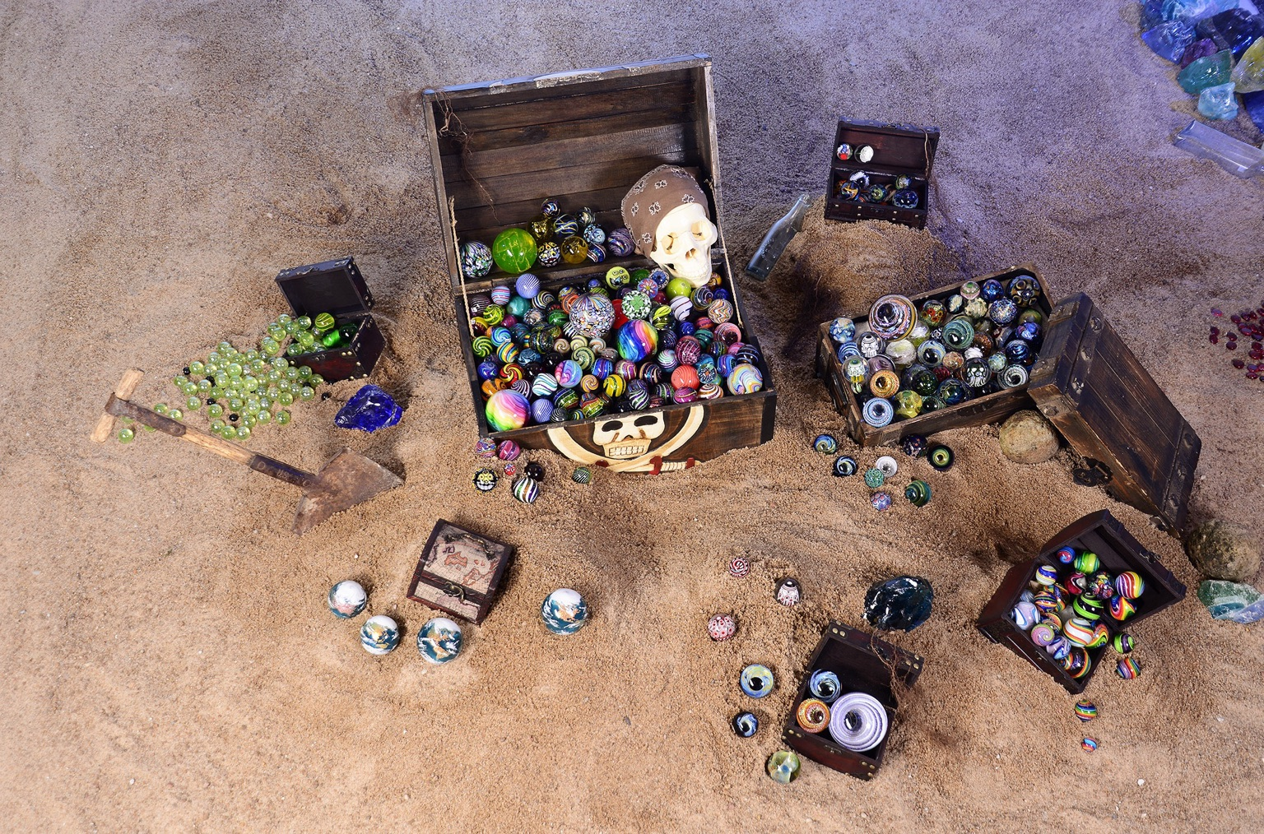 | 

25 SENSATIONAL STORY ANGLES FOR MEDIA
Record-setting history, real treasure, famous artists, free public adventure and worldwide community
THE WORLD'S BIGGEST ORGANIZED MULTI-CHEST TREASURE HUNT  A record-setting 385 registered chests are joining one unprecedented worldwide public adventure. | THE PUBLIC IS INVITED TO BE PART OF HISTORY  Families can follow the clues and participate in the record, not merely watch it.
ANYONE CAN HUNT FOR REAL TREASURE - COMPLETELY FREE  No ticket, purchase, admission fee or entry charge is required. | 385 TREASURE CHESTS SET A NEW WORLDWIDE RECORD  One coordinated hunt is launching hundreds of separate treasure adventures.
MORE THAN $60,000 IN ART AND TREASURE IS BEING GIVEN AWAY  Handmade art and real treasure are being placed into the hands of strangers and families. | YOU NEVER KNOW WHAT WILL BE INSIDE THE TREASURE CHEST  Cash, jewelry, gift cards, art, collectibles and surprises may accompany the marbles.
WORLD-FAMOUS ARTISTS ARE HIDING THEIR WORK AS TREASURE  Internationally recognized artists and leading glass studios are putting collectible work into the wild. | HUNDREDS OF CELEBRATED ARTISTS’ MARBLES ENTER THE HUNT  A remarkable range of respected makers will be represented inside the chests.
ONE-OF-A-KIND CONTEMPORARY ART BECOMES REAL TREASURE  Original glass art leaves studios and collections to begin a public adventure. | THESE ARE NOT ORDINARY TOY MARBLES  Individual handmade pieces may be worth $15 to hundreds or even thousands of dollars.
THOUSANDS OF ADDITIONAL HANDMADE MARBLES WILL BE HIDDEN WORLDWIDE  Beyond the 385 complete chests, individual marble hunts will place thousands more handmade marbles into communities around the globe. | THE WORLD’S LARGEST MARBLE-ART TREASURE COLLABORATION  Artists, studios, collectors, hunters and hiders are uniting on an unprecedented scale.
FROM ONE LEGENDARY CHEST TO 385 WORLDWIDE ADVENTURES  A separate 2022 milestone centered on one $45,000 chest; 2026 expands the idea worldwide. | THE TREASURES COULD APPEAR ALMOST ANYWHERE  Independent hiders choose the locations, so there is no public master map.
A WORLDWIDE TREASURE HUNT WITH NO CENTRAL HIDING PLACE  Hundreds of adventures are moving into communities rather than one destination. | A TREASURE HUNT THAT COULD CONTINUE FOR YEARS  Mystery locations and difficult clues may keep individual hunts alive for months or years.
LOCAL COMMUNITIES JOIN A HISTORIC GLOBAL EVENT  Every town, artist, studio and hider becomes part of one shared worldwide story. | A 40,000-PLUS-MEMBER COMMUNITY IS MAKING HISTORY  A global online community is creating hundreds of real-world adventures.
THE 10-YEAR PAY-IT-FORWARD MOVEMENT MAKES HISTORY AGAIN  A movement founded in 2016 celebrates by giving away more art and adventure than ever. | FINDERS CAN BECOME THE NEXT GENERATION OF HIDERS  The pay-it-forward model turns treasure hunters into creators of future adventures.
A FREE TREASURE HUNT COULD CREATE THOUSANDS OF NEW ART COLLECTORS  One discovery can introduce an entire family to contemporary handmade glass art. | FAMILY ADVENTURE MEETS FINE GLASS ART  Outdoor exploration, clues, mystery and collectible artwork come together in one event.
THE ARTISTS ARE NOT JUST PARTICIPATING - THEY ARE MAKING HISTORY  Every contributing artist and studio becomes part of the record-setting collaboration. | THE FINDERS BECOME PART OF THE WORLD RECORD  Every person who follows a clue and discovers treasure becomes part of the record-setting worldwide story.
ONE DATE LAUNCHES A WORLDWIDE ADVENTURE THAT LASTS ALL YEAR
The main hunt begins July 23, while new hides may continue through the end of 2026.
Each angle is written as a ready-to-use hook that can be shortened, combined or localized for television, print, radio, digital and social coverage.

